PART C – SOFTWARE REQUIREMENTS SPECIFICATIONS

USER REQUIREMENT SPECIFICATION
The system is an online assessment and testing tool that provides facilities for teachers create, reuse, and import tests. On this system, students are provided the environment and tools to do tests and monitor their results. Reporting tools help both teachers and students to easily monitor and evaluate student’s progress. Thereby, it is creating a high interaction between teachers and students.
More precisely, the system should offer the features listed below.

TEACHER REQUIREMENTS
A teacher should have the following abilities:
- View and modify personal information.
- Search and view existing tests in system.
- Create new tests.
- Modify existing tests.
- Create new question, remove questions, duplicate questions, reuses existing questions, import questions from other resources.
- Invite teachers and students to join tests (another teacher can modify the test’s content, and student can do tests).
- Setting test environment.
- Try doing tests.
- View reports of student scores, responses, keep tracking student’s progress.
- Receive feedbacks from students.

STUDENT REQUIREMENTS
A student should have the following abilities:
- View and modify personal information
- Search and view tests that available to him.
- Join tests, therefore doing tests.
- Receive invited tests notification from email.
- View reports of testing progress.
- Give feedback on tests to teachers.

SYSTEM REQUIREMENTS
The system should have the following features:
- Automatically grade student tests, except the writing parts.
- Automatically calculate score of a student.
- Automatically generate report of student testing progress (scores and overall score statistic).

SYSTEM REQUIREMENT SPECIFICATION (SPECIFIC REQUIREMENTS)

SYSTEM FEATURES
This section provides a short overview of all features. Each feature is a group of similar use cases which are given by the system to satisfy user requirements.
Users who can interact directly with the system can be divided into 5 kinds of actors as follows:

No. | Actor | Description
1 | Guest | Visitor who is not logged in to the system.
2 | User | Logged in guest.
3 | Teacher | User who has the ability to create and manage tests, invite another user join tests
4 | Student | User who has the ability to join a test, doing a test and give feedback to teachers
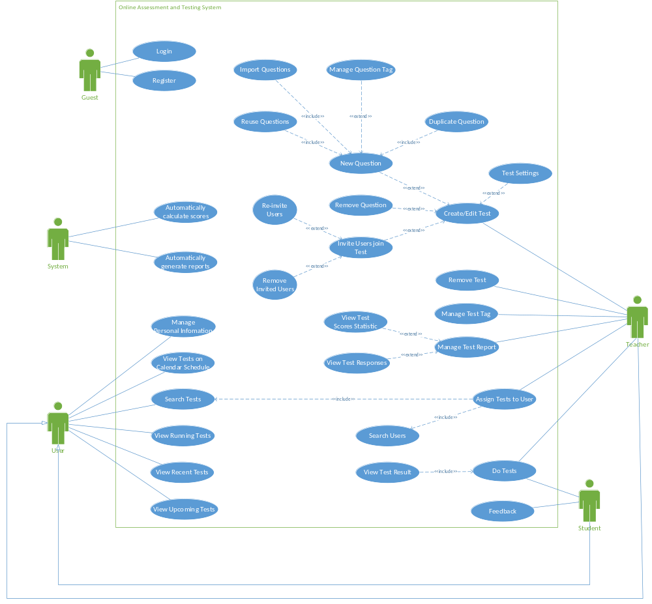Figure 1: Overall use case

USE CASE DIAGRAM AND USE CASE SPECIFICATION
GUEST FEATURES:
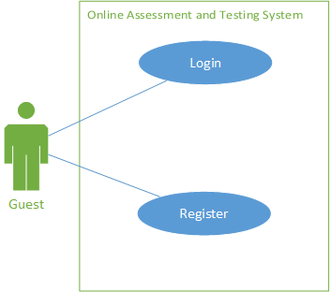
Figure 2: Guest Feature use case

<Guest>Register

Use case diagram
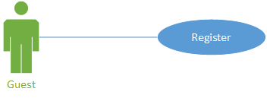

Use case description
USE CASE REGISTER SPECIFICATION
Use-case No. | UC001 | Use-case Version |  | 1.0
Use-case Name | Register
Author | TanND
Date | 28/05/2013 | Priority | Normal
Actor: Guest
Summary: A guest wants to be user of the system.
Goal: Guest becomes user of the system
Triggers: Guest clicks the “Sign up” button.
Preconditions: Home page is displayed without any errors.
Post Conditions: Guest becomes “User” of system. Guest can use all functions of “User” role.
Main Success Scenario:
Step | Actor Action | System Response
1 | Guest clicks “Sign up” button | Shows Register page with all fields in form: Email, password, phone, firstname, lastname, country.
2 | Fills mandatory fields and click “Sign up” button | Does validation, checks conflict and saves data into database.  Navigates backs to home page
Alternative Scenario:
Step | Actor Action | System Response
1 | Same as Main Success Scenario.
2 | Same as Main Success Scenario.
3 | Clicks other button or link | Navigates to specific page
Exceptions:
Step | Actor Action | System Response
1 | Same as Main Success Scenario.
2 | Does not fill all required field or enters invalid data | Display warning message to notify the missing field
Relationships: Login Use case
Business Rules: Username is valid in the system.

<Guest>Login

Use case diagram
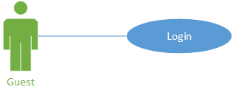

Use case description
USE CASE LOGIN SPECIFICATION
Use-case No. | UC002 | Use-case Version |  | 1.0
Use-case Name | Login
Author | TanND
Date | 28/05/2013 | Priority | Normal
Actor: Guest
Summary: A user who wants to create a test, do a test must login the system.
An admin who wants to manage data must login into the system.
Goal: Users can use the system in the way they want after log in.
Triggers: User accesses website’s Home page and clicks “Login” button
Preconditions: User must have an account in the system
Post Conditions: After logging in, user moves to website’s Home page with the information has logged in successfully (usermail is showed on the website)
Main Success Scenario:
Step | Actor Action | System Response
1 | Guest clicks “Login” button | Shows the Login page with all fields in form: Usermail, password.
2 | Fills all fields  Clicks “Login” | Checks the mail and password of user.  Logs user into the system.  Logs into website’s Home page with mail is showed

Alternative Scenario:
Step | Actor Action | System Response
1 | Same as Main Success Scenario.
2 | Click “Sign up” link | Shows the Register page
Exceptions:
Step | Actor Action | System Response
1 | Same as Main Success Scenario.
2 | Enter invalid (not registered username, wrong password) data and clicks “Login” | Shows “Wrong email or password” message.  Moves cursor to the Email control.

Relationships: Register Use Case
Business Rules: Guest who wants to use advanced function must login the system.

USER FEATURES:
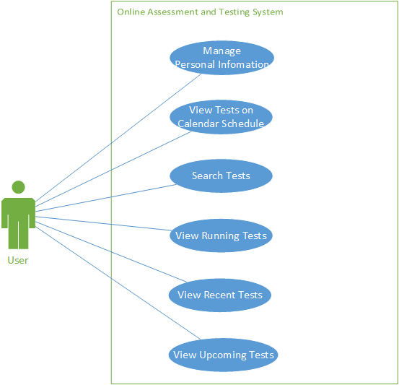
Figure 3: User feature use case

<User>Manage personal information

Use case diagram
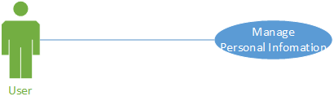

Use case description
USE CASE MANAGE PERSONAL INFORMATION SPECIFICATION
Use-case No. | UC003 | Use-case Version |  | 1.0
Use-case Name | Manage personal information
Author | TanND
Date | 28/05/2013 | Priority | Normal
Actor: Teacher, Student
Summary: This use case is about how a user changes name or password.
Goal: Users can changes name or password after log in.
Triggers: User accesses website’s Home page and clicks “User” icon.
Preconditions: Must be logged in and accessed homepage.
Post Conditions: Change name or password successful.
Main Success Scenario:
Step | Actor Action | System Response
1 | User clicks “User” icon in homepage. | Shows a dropdown list with “My login” option and “Log out” option.
2 | User clicks “My login” option in the dropdown list. | Show a pop up with all fields: Name, Current Password, New Password and Repeat Password.
3 | User fills in a field user want to change. (Name or “Current Password + New Password + Repeat Password”)  Clicks “Save” button | Checks the new password of user.  Close the pop up and save all changed into database.

Alternative Scenario:
Step | Actor Action | System Response
1 | Same as Main Success Scenario.
2 | Same as Main Success Scenario.
3 | Clicks “Cancel” button. | Close pop up.
Exceptions:
Step | Actor Action | System Response
1 | Same as Main Success Scenario.
2 | Same as Main Success Scenario.
3 | Enter invalid (wrong current password) data and clicks “Save” button | Highlight “Current password” field and show “Not valid” message.

Relationships: N/A
Business Rules: N/A.

<User>View Tests on Calendar Schedule

Use case diagram
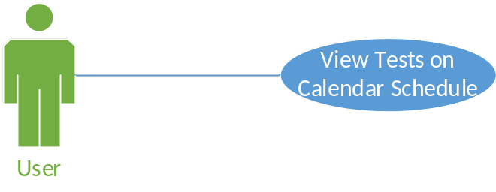

Use case description
USE CASE VIEW TESTS ON CALENDAR SCHEDULE SPECIFICATION
Use-case No. | UC004 | Use-case Version |  | 1.0
Use-case Name | View Tests On Calendar Schedule
Author | TanND
Date | 28/05/2013 | Priority | Normal
Actor: Student, Teacher
Summary: This use case is about viewing the tests on Calendar Schedule.
Goal: User can see the tests on Calendar Schedule.
Triggers: User clicks the “Calendar” tab.
Preconditions: Must be logged in and accessed homepage.
Post Conditions:
Main Success Scenario:
Step | Actor Action | System Response
1 | User clicks the “Calendar” tab in homepage. | Shows a calendar schedule with all tests in time.
Alternative Scenario:
Step | Actor Action | System Response
1 | Same as Main Success Scenario.
2 | Clicks other button or link | Navigates to specific page
Exceptions: If connection to database or server failed, show alert message indicate problem in server.
Relationships: N/A
Business Rules: N/A

<User>Search Tests

Use case diagram
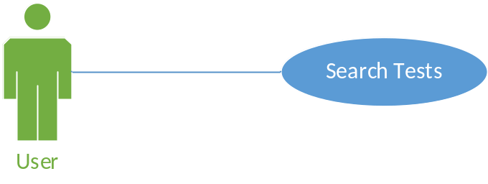

Use case description
USE CASE SEARCH TESTS SPECIFICATION
Use-case No. | UC005 | Use-case Version |  | 1.0
Use-case Name | Search Test
Author | TanND
Date | 28/05/2013 | Priority | Normal
Actor: Student, Teacher
Summary: A user wants to instant search tests in search box (System searches word-by-word, show instant result downside the search box).
Goal: System displays the desired result.
Triggers: User enters text in search box.
Preconditions: User has logged in system. The page with search box is displayed without any errors.
Post Conditions: Search results are displayed.
Main Success Scenario:
Step | Actor Action | System Response
1 | Accesses to Home page | Shows information about website
2 | User clicks to “Search box” panel
3 | User inputs search information in to text field | System will search word-by-word and show list instant result downside the search box

Alternative Scenario:
Step | Actor Action | System Response
1 | Same as Main Success Scenario.
2 | Same as Main Success Scenario.
3 | Same as Main Success Scenario.
4 | Clicks other button or link | Navigates to specific page.
Exceptions: If connection to database or server failed, show alert message indicate problem in server.
Relationships: Assign test to users use case.
Business Rules: N/A

<User>View Running Tests

Use case diagram
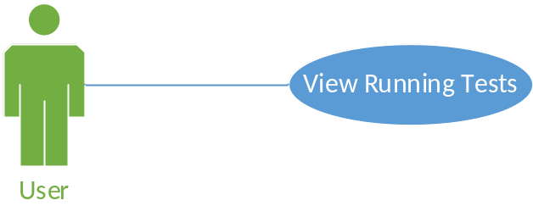

Use case description
USE CASE VIEW RUNNING TESTS SPECIFICATION
Use-case No. | UC006 | Use-case Version |  | 1.0
Use-case Name | View Running Tests
Author | TanND
Date | 28/05/2013 | Priority | Normal
Actor: Student, Teacher
Summary: This use case is about viewing the tests are running.
Goal: User can see the tests are running.
Triggers: User clicks the “Running test” tab.
Preconditions: Must be logged in and accessed homepage.
Post Conditions:
Main Success Scenario:
Step | Actor Action | System Response
1 | User clicks the “Running test” tab in homepage. | Shows a table with all tests is running.
Alternative Scenario:
Step | Actor Action | System Response
1 | Same as Main Success Scenario.
2 | Clicks other button or link | Navigates to specific page
Exceptions: If connection to database or server failed, show alert message indicate problem in server.
Relationships: N/A.
Business Rules: Retrieve tests that start time and end time is over today.

<User>View recent tests

Use case diagram
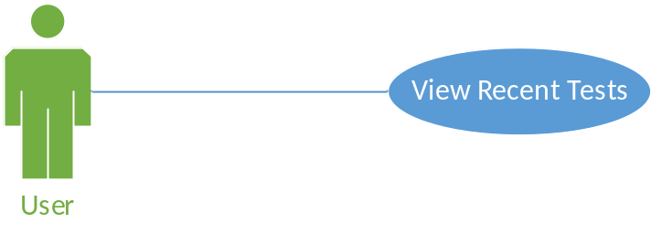

Use case description
USE CASE VIEW RECENT TESTS SPECIFICATION
Use-case No. | UC007 | Use-case Version |  | 1.0
Use-case Name | View Recent Tests
Author | TanND
Date | 28/05/2013 | Priority | Normal
Actor: Student, Teacher
Summary: This use case is about viewing the tests are in past.
Goal: User can see the tests are in past.
Triggers: User clicks the “Recent test” tab.
Preconditions: Must be logged in and accessed homepage.
Post Conditions:
Main Success Scenario:
Step | Actor Action | System Response
1 | User clicks the “Recent test” tab in homepage. | Shows a table with all tests is in past.
Alternative Scenario:
Step | Actor Action | System Response
1 | Same as Main Success Scenario.
2 | Clicks other button or link | Navigates to specific page
Exceptions: If connection to database or server failed, show alert message indicate problem in server.
Relationships: N/A.
Business Rules: Retrieve tests that start and end time currently available.

<User>View upcoming tests

Use case diagram
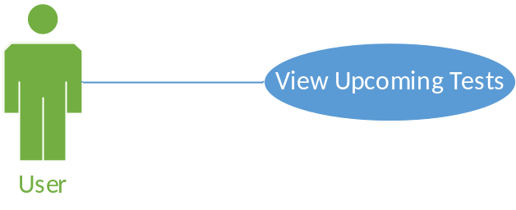

Use case description
USE CASE VIEW UPCOMING TESTS SPECIFICATION
Use-case No. | UC008 | Use-case Version |  | 1.0
Use-case Name | View Upcoming test.
Author | TanND
Date | 28/05/2013 | Priority | Normal
Actor: Student, Teacher
Summary: This use case is about viewing the upcoming tests.
Goal: User can see the upcoming tests.
Triggers: User clicks the “Upcoming test” tab.
Preconditions: Must be logged in and accessed homepage.
Post Conditions:
Main Success Scenario:
Step | Actor Action | System Response
1 | User clicks the “Upcoming test” tab in homepage. | Shows a table with all upcoming tests.
Alternative Scenario:
Step | Actor Action | System Response
1 | Same as Main Success Scenario.
2 | Clicks other button or link | Navigates to specific page
Exceptions: If connection to database or server failed, show alert message indicate problem in server.
Relationships: N/A.
Business Rules: Retrieve tests that will available in future.

STUDENT FEATURES:
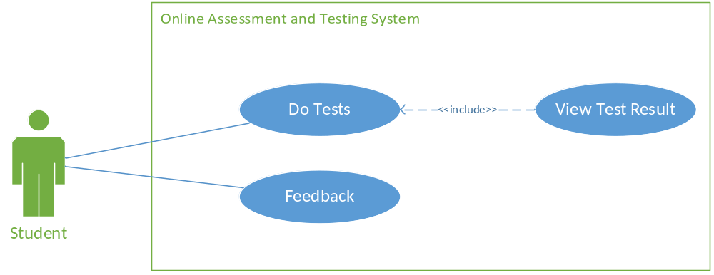
Figure 4: Student Feature use case

<Student>Do Tests

Use case diagram
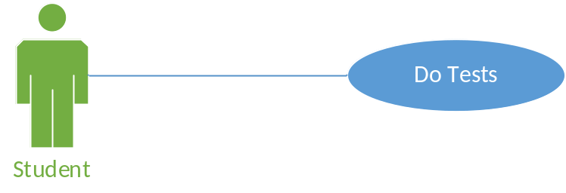

Use case description
USE CASE DO TESTS SPECIFICATION
Use-case No. | UC009 | Use-case Version |  | 1.0
Use-case Name | Do Tests
Author | TanND
Date | 30/05/2013 | Priority | Normal
Actor: Student
Summary: System provides function to do a test.
Goal: Help user do a test.
Triggers: Click Test title.
Preconditions: User has logged in the system. The test is assigned to user.
Post Conditions: User can do a test and submit to the system.
Main Success Scenario:
Step | Actor Action | System Response
1 | User clicks “Running Test” tab. | Shows a table with all tests is running.
2 | User clicks Test title. | Shows Test Content page with all questions in the test.
3 | Select correct answer for each question. | Saves data in database.
4 | User clicks “Submit” button. | Navigates to homepage.
Alternative Scenario:
Step | Actor Action | System Response
1 | Same as Main Success Scenario.
2 | Same as Main Success Scenario.
3 | Clicks other button or link | Navigates to specific page
Exceptions: If connection to database or server failed, show alert message indicate problem in server.
Relationships: N/A
Business Rules:
- Quiz is opened in a pre-defined period of time (set by teacher).
After this time, the quiz will be closed, that means students cannot retake it.
- By default, each quiz is set to allow only one attempt.
In case student got problem when submitting, he/she should ask the teacher for the second attempt..
- Test reports include completed date and submit status.

<Student>Feedback

Use case diagram
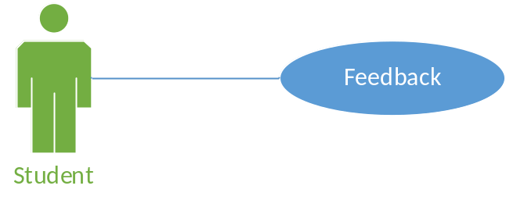

Use case description
USE CASE FEEDBACK SPECIFICATION
Use-case No. | UC010 | Use-case Version |  | 1.0
Use-case Name | Feedback
Author | TanND
Date | 30/05/2013 | Priority | Normal
Actor: Student
Summary: System provides function to feedback about a test.
Goal: Help user feedback about a test.
Triggers: User’s behavior.
Preconditions: User has logged in the system. The test is allowed to feedback.
Post Conditions: User cans feedbacks about a test.
Main Success Scenario:
Step | Actor Action | System Response
1 | Clicks on “Feedback” icon beside each “Test Title” links in “Recent Test”, “Upcoming Test”, “Running Test” tab, in “Calendar” tab. | Shows the “Feedback” page with 4 default questions about the test, one filed to write user’s opinion, “Feedback” button and “Cancel” button.
2 | User answers all questions and fills in field.  Clicks “Feedback” button. | Shows message “Feedback successful!” and navigates to homepage.  Save data into database.
Alternative Scenario:
Step | Actor Action | System Response
1 | Same as Main Success Scenario.
2 | Clicks “Cancel” button. | Navigates to homepage.
Exceptions: If connection to database or server failed, show alert message indicate problem in server.
Relationships: N/A
Business Rules: N/A
TEACHER FEATURES:
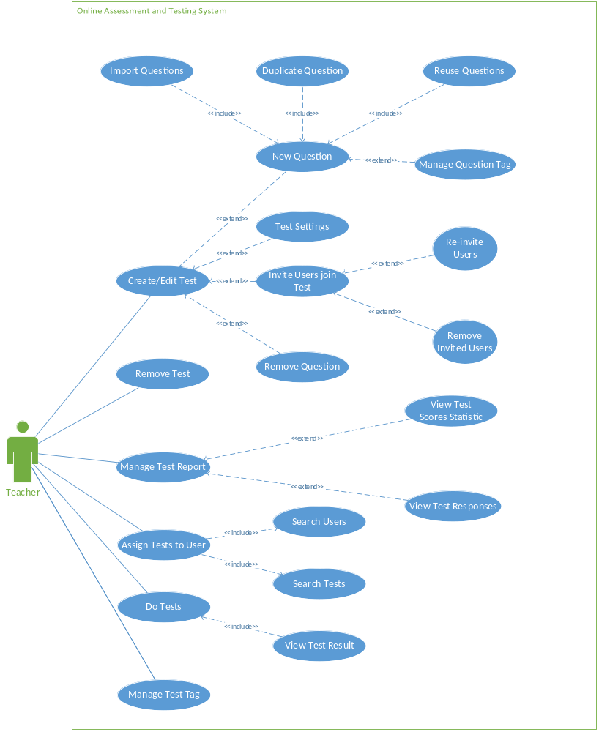
Figure 5: Teacher feature use case

<Teacher> Create/Edit test

Use case diagram
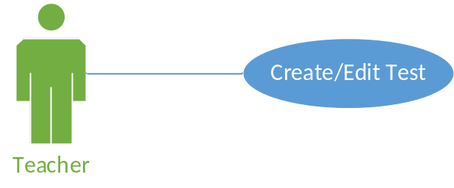

Use case description
USE CASE CREATE/EDIT TEST SPECIFICATION
Use-case No. | UC011 | Use-case Version |  | 1.0
Use-case Name | Create/edit Test
Author | TanND
Date | 31/05/2013 | Priority | Normal
Actor: Teacher.
Summary: This use case describes how the teacher creates or edits a test.
Goal: For teacher creates or edits a test.
Triggers: This use case starts when the teacher clicks “New” button in “Test” page or clicks on search result item of searching tests.
Preconditions: User logged into the system.
Post Conditions: Test is created, existing test is modified.
Main Success Scenario:
Step | Actor Action | System Response
1 | User clicks in Test tab in Homepage | Navigates to Test page.
2 | User clicks “New” button or click on search result item of searching tests | Navigates to Test Content page with all question type.
3 | User chooses a question type and fills all detail. | Show a new question and save into database.
Alternative Scenario:
Step | Actor Action | System Response
1 | Same as Main Success Scenario.
2 | Same as Main Success Scenario.
3 | Same as Main Success Scenario.
4 | Clicks other button or link | Navigates to specific page.
Exceptions: If connection to database or server failed, show alert message indicate problem in server.
Relationships: N/A
Business Rules: N/A

<Teacher> Import Questions

Use case diagram
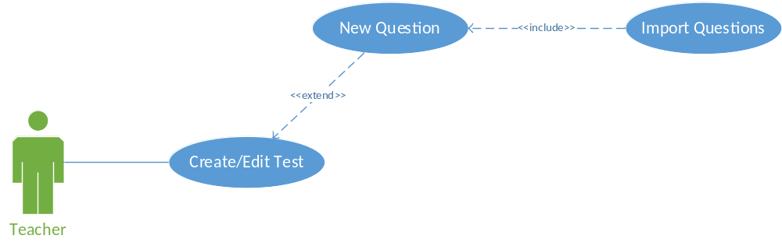

Use case description
USE CASE IMPORT QUESTIONS SPECIFICATION
Use-case No. | UC012 | Use-case Version |  | 1.0
Use-case Name | Import Questions
Author | TanND
Date | 31/05/2013 | Priority | Normal
Actor: Teacher.
Summary: This use case describes how the teacher imports a question.
Goal: For teacher imports a question.
Triggers: User’s behavior.
Preconditions: User logged into the system.
Post Conditions: Imports question successful.
Main Success Scenario:
Step | Actor Action | System Response
1 | User clicks in Test tab in Homepage | Navigates to Test page.
2 | User clicks “New” button | Navigates to Test Content page with all question type.
3 | User clicks “Import Question” tab | Change from “Question” tab to “Import question” tab.
4 | User clicks “Import question” box.
5 | Copy-paste or drag-drop any number of questions (with answers). | Import them into Test Content and save all changed into database.
Alternative Scenario:
Step | Actor Action | System Response
1 | Same as Main Success Scenario.
2 | Same as Main Success Scenario.
3 | Same as Main Success Scenario.
4 | Same as Main Success Scenario.
5 | Same as Main Success Scenario.
6 | Clicks other button or link | Navigates to specific page.
Exceptions: If connection to database or server failed, show alert message indicate problem in server.
Relationships: N/A
Business Rules: N/A

<Teacher> Duplicate Question

Use case diagram
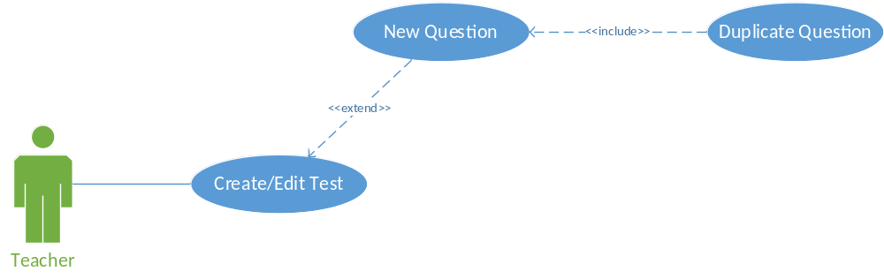

Use case description
USE CASE DUPLICATE QUESTION SPECIFICATION
Use-case No. | UC013 | Use-case Version |  | 1.0
Use-case Name | Duplicate Question
Author | TanND
Date | 31/05/2013 | Priority | Normal
Actor: Teacher.
Summary: This use case describes how the teacher duplicates a question.
Goal: For teacher duplicates a question.
Triggers: User’s behavior.
Preconditions: User logged into the system.
Post Conditions: Duplicates question successful.
Main Success Scenario:
Step | Actor Action | System Response
1 | User clicks in Test tab in Homepage | Navigates to Test page.
2 | User clicks “New” button | Navigates to Test Content page with all question type.
3 | User chooses a question type and fills all detail. | Show a new question and save all changed into database.
4 | User clicks “Duplicate” button in top-left of a question. | Create a copy question and save all changed into database
Alternative Scenario:
Step | Actor Action | System Response
1 | Same as Main Success Scenario.
2 | Same as Main Success Scenario.
3 | Same as Main Success Scenario.
4 | Same as Main Success Scenario.
5 | Clicks other button or link | Navigates to specific page.
Exceptions: If connection to database or server failed, show alert message indicate problem in server.
Relationships: Create Question use case
Business Rules: N/A

<Teacher> Reuse Question

Use case diagram
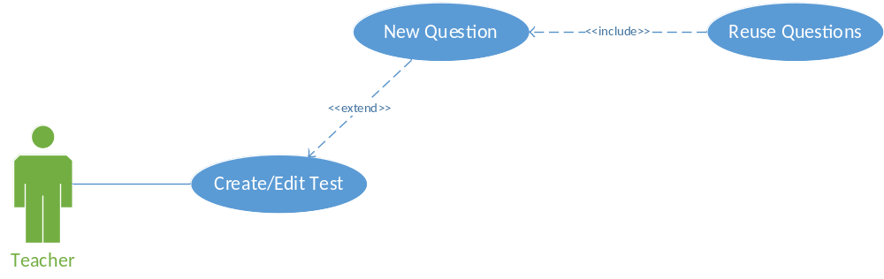

Use case description
USE CASE REUSE QUESTION SPECIFICATION
Use-case No. | UC014 | Use-case Version |  | 1.0
Use-case Name | Reuse Questions
Author | TanND
Date | 31/05/2013 | Priority | Normal
Actor: Teacher.
Summary: This use case describes how the teacher reuses questions.
Goal: For teacher reuses questions.
Triggers: User’s behavior.
Preconditions: User logged into the system.
Post Conditions: Reuses question successful.
Main Success Scenario:
Step | Actor Action | System Response
1 | User clicks in Test tab in Homepage | Navigates to Test page.
2 | User clicks “New” button | Navigates to Test Content page with all question type.
3 | User clicks “Reuse questions” tab | Change from “Question” tab to “Reuse questions” tab.
4 | User clicks “Search questions” box.
5 | User inputs search information. | System will search word-by-word and show list instant result downside the search box.
6 | User clicks an item result. | Create a new question and save all changed into database.
Alternative Scenario:
Step | Actor Action | System Response
1 | Same as Main Success Scenario.
2 | Same as Main Success Scenario.
3 | Same as Main Success Scenario.
4 | Same as Main Success Scenario.
5 | Same as Main Success Scenario.
6 | Same as Main Success Scenario.
7 | Clicks other button or link | Navigates to specific page.
Exceptions: If connection to database or server failed, show alert message indicate problem in server.
Relationships: N/A
Business Rules: N/A

<Teacher> Manage Question Tag

Use case diagram
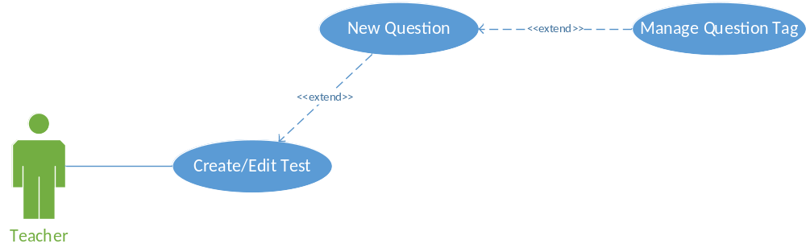

Use case description
USE CASE MANAGE QUESTION TAG SPECIFICATION
Use-case No. | UC015 | Use-case Version |  | 1.0
Use-case Name | Manage Question Tag
Author | TanND
Date | 31/05/2013 | Priority | Normal
Actor: Teacher.
Summary: This use case describes how the teacher manages question tag.
Goal: For teacher manages question tag.
Triggers: User’s behavior.
Preconditions: User logged into the system.
Post Conditions: Can create new tag or remove tag of a question.
Main Success Scenario:
Step | Actor Action | System Response
1 | User clicks in Test tab in Homepage | Navigates to Test page.
2 | User clicks “New” button | Navigates to Test Content page with all question type.
3 | User chooses a question type and fills all detail. | Show a new question and save all changed into database.
4 | User clicks “Add tag” box in bottom of question.
5 | User inputs tag name. | Create a new tag of this question and save all changed into database.
6 | User clicks “Remove tag” button. | Delete a tag and save all changed into database
Alternative Scenario:
Step | Actor Action | System Response
1 | Same as Main Success Scenario.
2 | Same as Main Success Scenario.
3 | Same as Main Success Scenario.
4 | Same as Main Success Scenario.
5 | Same as Main Success Scenario.
6 | Same as Main Success Scenario.
7 | Clicks other button or link | Navigates to specific page.
Exceptions: If connection to database or server failed, show alert message indicate problem in server.
Relationships: Create Question use case
Business Rules:

<Teacher> Test Setting

Use case diagram
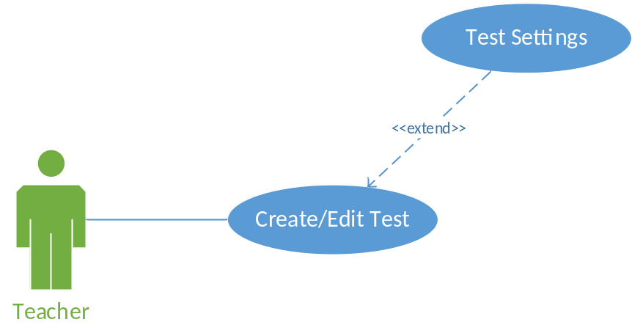

Use case description
USE CASE TEST SETTING SPECIFICATION
Use-case No. | UC016 | Use-case Version |  | 1.0
Use-case Name | Test Setting
Author | TanND
Date | 30/05/2013 | Priority | Normal
Actor: Teacher.
Summary: This user case describes how the teacher manages test setting.
Goal: For teacher to manage test setting.
Triggers: This use case starts when the teacher wishes to manage test setting.
Preconditions: User logged in to the system.
Post Conditions: Teacher can configure test setting.
Main Success Scenario:
Step | Actor Action | System Response
1 | User clicks in Test title | Navigates to Test Config page
2 | User clicks “Settings” tab | Navigates to Test Setting page with three main option: Test Access Control, Results & Reporting, Test Formatting
3 | User chooses option. | Saves all changed in database.
Alternative Scenario:
Step | Actor Action | System Response
1 | Same as Main Success Scenario.
2 | Same as Main Success Scenario.
3 | Clicks other button or link | Navigates to specific page.

Exceptions: If connection to database or server failed, show alert message indicate problem in server.
Relationships: N/A
Business Rules: N/A

<Teacher> Invite Users Join Test

Use case diagram
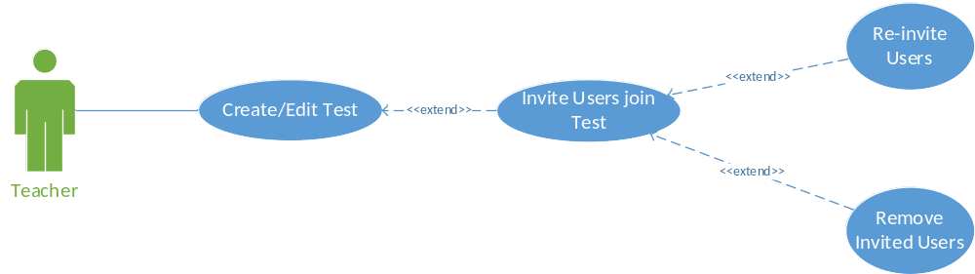

Use case description
USE CASE INVITE USERS JOIN TEST SPECIFICATION
Use-case No. | UC017 | Use-case Version |  | 1.0
Use-case Name | Invite users join test
Author | TanND
Date | 30/05/2013 | Priority | Normal
Actor: Teacher.
Summary: This user case describes how the teacher invite users join test.
Goal: For teacher to invite user join test.
Triggers: User’s behavior.
Preconditions: User logged in to the system.
Post Conditions: Invite user join test successful.
Main Success Scenario:
Step | Actor Action | System Response
1 | User clicks in Test tab in Homepage | Navigates to Test page.
2 | Click on “Test Title” links below each table in “Recent Test”, “Upcoming Test”, “Running Test” tab, in “Calendar” tab.  Choose result item as a Test while searching Test Title in “Search” function. | Navigates to Test Content page.
3 | User clicks “Invitation” tab. | Navigates to “Test Invitation” page.
4 | Clicks “Invite more users” (“Invite more Students” or “Invite more Educators”) button. | Shows a pop up with “Search” box, “Invite button” and “Cancel button”.
5 | Clicks “Search” box and fills keywords to search user. | System will search word-by-word and show list instant result downside the search box
6 | Choose result item and clicks “Invite” button. | Close the pop up.  Send a mail to user who is invited.  Assign this test to user who is invited.

Alternative Scenario:
Step | Actor Action | System Response
1 | Same as Main Success Scenario.
2 | Same as Main Success Scenario.
3 | Same as Main Success Scenario.
4 | Same as Main Success Scenario.
5 | Same as Main Success Scenario.
6 | Clicks “Cancel” button. | Close the pop up.

Exceptions: If connection to database or server failed, show alert message indicate problem in server.
Relationships: Create/Edit test.
Business Rules: N/A

<Teacher> Remove Question

Use case diagram
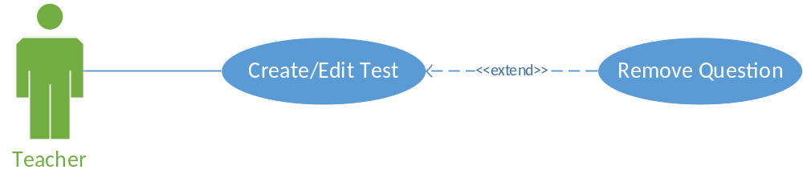

Use case description
USE CASE REMOVE QUESTION SPECIFICATION
Use-case No. | UC018 | Use-case Version |  | 1.0
Use-case Name | Remove Question
Author | TanND
Date | 31/05/2013 | Priority | Normal
Actor: Teacher.
Summary: This use case describes how the teacher removes a question.
Goal: For teacher removes a question.
Triggers: User’s behavior.
Preconditions: User logged into the system.
Post Conditions: Removes question successful.
Main Success Scenario:
Step | Actor Action | System Response
1 | User clicks in Test tab in Homepage | Navigates to Test page.
2 | User clicks “New” button | Navigates to Test Content page with all question type.
3 | User chooses a question type and fills all detail. | Show a new question and save all changed into database.
4 | User clicks “Remove” button in top-left of a question. | Delete a question and save all changed into database
Alternative Scenario:
Step | Actor Action | System Response
1 | Same as Main Success Scenario.
2 | Same as Main Success Scenario.
3 | Same as Main Success Scenario.
4 | Same as Main Success Scenario.
5 | Clicks other button or link | Navigates to specific page.
Exceptions: If connection to database or server failed, show alert message indicate problem in server.
Relationships: Create Question use case
Business Rules: N/A

<Teacher> Remove Test

Use case diagram
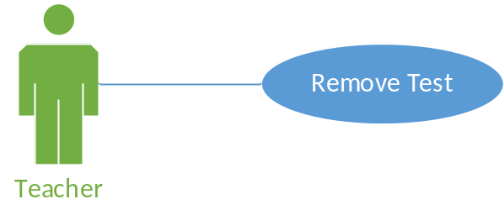

Use case description
USE CASE REMOVE TEST SPECIFICATION
Use-case No. | UC019 | Use-case Version |  | 1.0
Use-case Name | Remove Test
Author | TanND
Date | 31/05/2013 | Priority | Normal
Actor: Teacher.
Summary: This use case describes how the teacher removes a test.
Goal: For teacher removes a test.
Triggers: User’s behavior.
Preconditions: User logged into the system and has at least a test.
Post Conditions: Removes test successful.
Main Success Scenario:
Step | Actor Action | System Response
1 | User clicks in Test tab in Homepage | Navigates to Test page.
2 | Click on “Test Title” links below each table in “Recent Test”, “Upcoming Test”, “Running Test” tab, in “Calendar” tab.  Choose result item as a Test while searching Test Title in “Search” function. | Navigates to Test Content page.
3 | User clicks “Delete” icon (“X” icon) | Show a pop up message “Are you sure you want to delete this test?”, “OK” button, “Cancel” button.
4 | User clicks “OK” button. | Delete a test and save all changed into database.  Close the pop up.  Navigates to homepage.
Alternative Scenario:
Step | Actor Action | System Response
1 | Same as Main Success Scenario.
2 | Same as Main Success Scenario.
3 | Same as Main Success Scenario.
4 | Clicks “Cancel” button | Close the pop up.
Exceptions: In any case of failure, system will show error message. Execution is rolled back, database is not changed.
Relationships: Create/Edit Test use case
Business Rules: N/A

<Teacher> Manage Test Report

Use case diagram
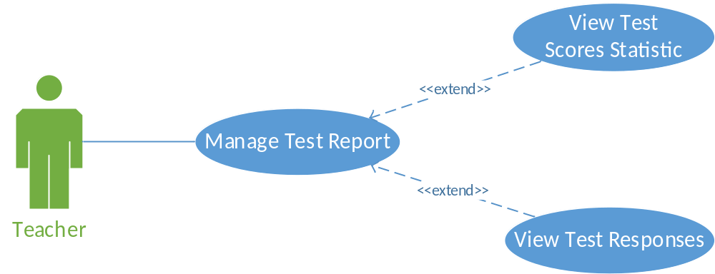

Use case description

<Teacher> Assign Tests to User

Use case diagram
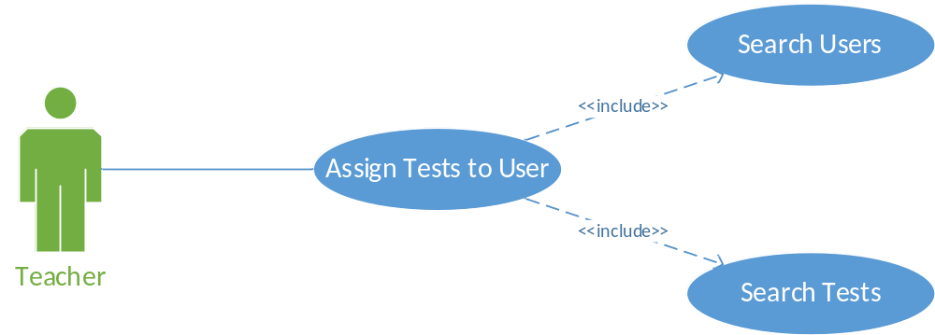

Use case description
USE CASE ASSIGN TESTS TO USER SPECIFICATION
Use-case No. | UC021 | Use-case Version |  | 1.0
Use-case Name | Assign Tests to User
Author | TanND
Date | 30/05/2013 | Priority | Normal
Actor: Teacher.
Summary: System provides function to assign tests to a user.
Goal: Help user assigns tests to another user.
Triggers: User’s behavior.
Preconditions: User has logged in the system and has at least a test.
Post Conditions: User can assign tests to another user.
Main Success Scenario:
Step | Actor Action | System Response
1 | Teacher clicks “User” tab (Teacher/Student tab). | Navigates to User page (Teacher/Student page).
2 | Teacher searches another user in “Search” box and clicks result item.  Click “New” button and add new user. | Show user’s status (All running tests and past tests).
3 | Search a test in “Search Test” box and click result item. | Assign this test to the user.
Alternative Scenario:
Step | Actor Action | System Response
1 | Same as Main Success Scenario.
2 | Same as Main Success Scenario.
3 | Same as Main Success Scenario.
4 | Clicks “UNASSIGN” button. | Not assign this test to user.
Exceptions: If connection to database or server failed, show alert message indicate problem in server.
Relationships: Search Teacher use case, Search Student use case.
Business Rules: N/A

<Teacher> Manage Test Tag

Use case diagram
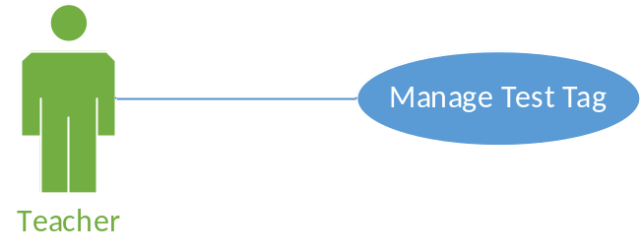

Use case description
USE CASE MANAGE TEST TAG SPECIFICATION
Use-case No. | UC022 | Use-case Version |  | 1.0
Use-case Name | Manage Test Tag
Author | TanND
Date | 31/05/2013 | Priority | Normal
Actor: Teacher.
Summary: This use case describes how the teacher manages a test tag.
Goal: For teacher manages test tag.
Triggers: User’s behavior.
Preconditions: User logged into the system.
Post Conditions: Add new or remove tag successful.
Main Success Scenario:
Step | Actor Action | System Response
1 | User clicks in Test tab in Homepage | Navigates to Test page.
2 | User clicks “New” button.  Or click on “Test Title” links below each table in “Recent Test”, “Upcoming Test”, “Running Test” tab, in “Calendar” tab.  Or choose result item as a Test while searching Test Title in “Search” function. | Navigates to Test Content page.
3 | User clicks “Add tag” box in top of the test.
4 | User inputs tag name. | Create a new tag of this test and save all changed into database.
5 | User clicks “Remove tag” icon. | Delete a tag and save all changed into database.
Alternative Scenario:
Step | Actor Action | System Response
1 | Same as Main Success Scenario.
2 | Same as Main Success Scenario.
3 | Same as Main Success Scenario.
4 | Same as Main Success Scenario.
5 | Same as Main Success Scenario.
6 | Clicks other button or link. | Navigates to specific page.
Exceptions: In any case of failure, system will show error message. Execution is rolled back, database is not changed.
Relationships: Create/Edit Test use case
Business Rules: N/A

SYSTEM FEATURES:
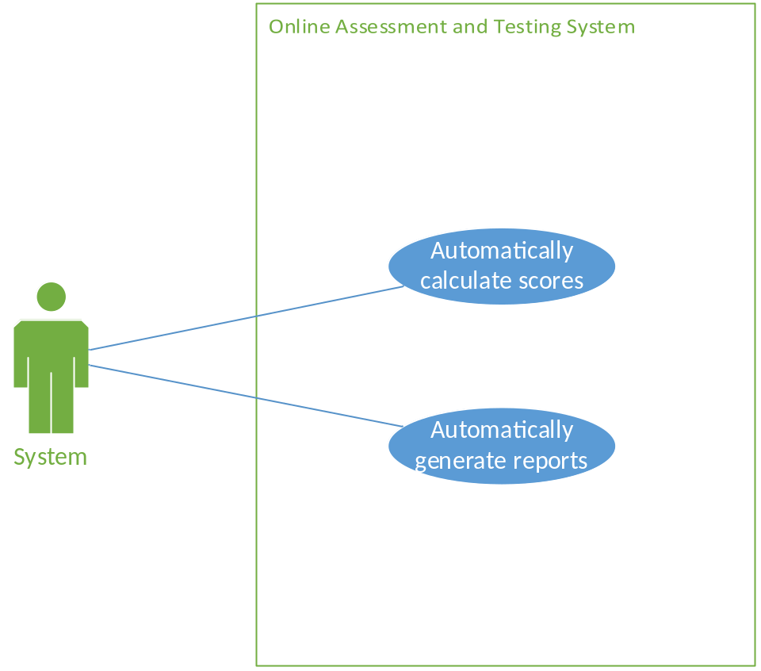
Figure 6: System feature use case

<System> Auto calculate scores

Use case diagram
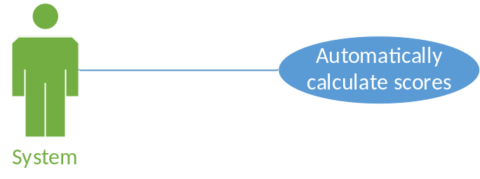

Use case description
USE CASE AUTO CALCULATE SCORES SPECIFICATION
Use-case No. | UC023 | Use-case Version |  | 1.0
Use-case Name | Auto calculate scores
Author | TuHM
Date | 06/06/2013 | Priority | Normal
Actor: System.
Summary: This use case describes how system auto calculate score
Goal: For system auto calculate score after student test.
Triggers: User’s behavior.
Preconditions: Student submitted test.
Post Conditions: Auto calculates and displays scores.
Main Success Scenario:
Step | Actor Action | System Response
1 | User clicks “Running Test” tab. | Shows a table with all tests is running.
2 | User clicks Test title. | Shows Test Content page with all questions in the test.
3 | Select correct answer for each question. | Saves data in database.
4 | User clicks “Submit” button. | System auto calculates score. If setting “Show question point value” is active, and display for student.
Alternative Scenario:
Step | Actor Action | System Response
1 | Same as Main Success Scenario.
2 | Same as Main Success Scenario.
3 | Same as Main Success Scenario.
4 | Clicks other button or link | Navigates to specific page
Exceptions: In any case of failure, system will show error message. Execution is rolled back, database is not changed.
Relationships: Do Test use case
Business Rules: N/A

<System> Auto generate reports

Use case diagram
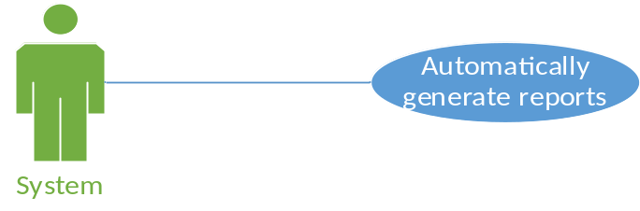

Use case description
USE CASE AUTO GENERATE REPORTS SPECIFICATION
Use-case No. | UC023 | Use-case Version |  | 1.0
Use-case Name | Auto generate reports
Author | TuHM
Date | 06/06/2013 | Priority | Normal
Actor: System.
Summary: This use case describes how system auto generate reports
Goal: For system auto generate report after student test.
Triggers: User’s behavior.
Preconditions: Student submitted test.
Post Conditions: Auto generate report base on student result.
Main Success Scenario:
Step | Actor Action | System Response
1 | Student clicks “Running Test” tab. | Shows a table with all tests is running.
2 | Student clicks Test title. | Shows Test Content page with all questions in the test.
3 | Select correct answer for each question. | Saves data in database.
4 | Student clicks “Submit” button. | System auto calculates score. If setting “Show question point value” is active, and display for student.
5 | Teacher open a test by search on home page | Show test content
6 | Teacher click score tab | Report is generated.
Alternative Scenario:
Step | Actor Action | System Response
1 | Same as Main Success Scenario.
2 | Same as Main Success Scenario.
3 | Same as Main Success Scenario.
4 | Same as Main Success Scenario.
5 | Same as Main Success Scenario.
6 | Clicks other button or link | Navigates to specific page
Exceptions: In any case of failure, system will show error message. Execution is rolled back, database is not changed.
Relationships: Do Test use case
Business Rules: N/A

SOFTWARE SYSTEM ATTRIBUTES

Reliability
When user needs to log in to the website over a given period of time for using some specified services, the system should deliver those services as user’s expectation. The system must be prevented from producing unexpected situation or incorrect output. Based on the situation and users’ operation, reliability requirement can be different. However, in general, system must ensure the followings:
- Certain system functions are visible for only appreciate user, e.g. only administrators can manage permission on their tests.
- Give appropriate response to user operation, e.g. moving from screen to screen.
- Give accurate result to user operation, e.g. searching or report generating.
- In case of failure, system must keep records to make sure user operation such as creating test contents, doing tests can be recovered with minimum loss of user input.

Availability
The system has to run 24/7 that means when any request at any given time is coming, the system should be available and able to respond. Therefore, to guarantee availability level for the entire system, some factors are required:
- Recovery from system failure
- Restarting after system failure
- Backing up data after a specific period of time, e.g. once per day

Security
There is no specific security requirement. In general:
- Only user with valid account and appropriate role can access certain system functions.
- Prevent everyone, including system administrator, from knowing users’ passwords, except the owner. When forgetting password, user can request system admin to reset their password and receive a new one.
- Keep specific log and history data
- Check data integrity and validate input before execute recording into system

Maintainability
When the system is deployed, there may be new or extra requirements. So that the system itself must be changeable that means development process must provide the ease to modify and extend. For the need to be easy to maintain, even though for new software team:
- Delivery product must have the software application packaged with all documented software requirements, software design, testing report and other material if any.
- For source code, all files and modules should have java doc and/or comment with short description and records of modification.
- In case of maintenance, a maintaining message should be shown to users when they enter to the website.

Portability
Any personal computer, which has an internet browser, is able to use this system. Therefore, the website must be developed and tested to make sure it can run smoothly with some popular web browsers, such as Internet Explorer, Mozilla Firefox and Google Chrome.

Performance
The system should use the memory and processor in most efficient way. Additionally, it should cost the least time interval for user to finish their operation. Hence, screen layout, color block, style sheet and all web controls should be well arranged and easy to use, in order to help users save their time when interacting with the system.

ENTITY RELATIONSHIP DIAGRAM
